The CRISP-DM Process Model

Project: Cross Domain Recommendation

Project Group 12

Students:
Ori Sinvani – 325770824
Yoav Silman – 318607694
Tamir Spivak – 326174596
Nehoray Chalfon – 325833531

Data Understanding

2.1 Collect Initial Data

Task Collect Initial Data
Acquire within the project the data (or access to the data) listed in the project resources. This initial collection includes data loading if necessary for data understanding. For example, if you intend to use a specific tool for data understanding, it is logical to load your data into this tool

Output Initial Data Collection Report
List all the various data that will be used within the project, together with any selection requirements for more detailed data. The Data Collection Report should also define whether some attributes are relatively more important than others.
Remember that any assessment of Data Quality should be made not just of the individual data sources but also of any data that comes from merging data sources. Merged data may present problems that do not exist in the individual data sources because of inconsistencies between the sources

Source and acquisition
Source: Amazon Reviews 2023. The corpus is licensed for academic use; no live or operational platform data is involved, and user/item identifiers in the public release are dataset-generated tokens rather than platform PII.
Acquisition: Files were pulled via the official huggingface_hub Python client. Total size is ~22.6 GB across 10 files (5 ratings tables + 5 metadata tables). The footprint sits well inside the project's compute constraint (200 GB working budget on the home workstation).
Data requirements planning
Interactions: for each vertical, who interacted with what, and when — the implicit-positive signal the recommender is trained on. The unfiltered (0-core) variant of the ratings table was chosen on purpose. A k-core filter repeatedly removes users and items with fewer than k interactions until every remaining user and item has at least k, so 0-core means no filtering at all, while 5-core keeps only users and items with at least five interactions each. Taking the 0-core table lets us run the 5-core filter ourselves on a pinned snapshot, whereas the release's pre-cored variants would lock in a filtering policy we want to be able to vary in ablations.
Item metadata: the cross-vertical bridge is item-side text and taxonomy — title, description, features, and the hierarchical category path — together with structured per-item attributes that vary by vertical (publisher and ISBN for books, directors for movies, runtime for music, manufacturer for games and toys). We pull the full per-vertical metadata table to cover all of these in one place.
Shared users: the cross-domain mapping function is supervised on users who appear in both source and target verticals. This is not a separate file — the corpus uses the same user identifier across verticals by construction, so the overlap is recovered by intersecting the user columns of two ratings tables. The actual overlap size after 5-core filtering is the gating check for §S2 and the central question of §2.3.
Temporal coverage: every interaction carries a timestamp (integer milliseconds since epoch), so the full multi-year review history of each vertical is retained at collection time rather than truncated to a fixed recent window. CRISP-DM prompts the team to decide how much history to use even when more is available; that decision is deferred to §2.3, where per-vertical timestamp coverage is profiled and a time-based train / validation / test split is defined. Retaining the entire history at this stage keeps that cut-off an evidence-based choice rather than prematurely discarding older interactions that may anchor long-lived user preferences feeding the cross-domain mapping.
Selection criteria
Selection was applied at three levels, narrowing from the whole corpus down to individual fields: which verticals to download, which file variants to take for each vertical, and which fields within a record we expect to actually consume. Each level is treated in turn below.
(a) Verticals. The 2023 corpus is partitioned into 33 top-level store categories. From these we kept only the entertainment-media cluster. Books, Movies_and_TV, CDs_and_Vinyl, Video_Games, and Toys_and_Games.
(b) File variants per vertical. For each vertical we keep two tables: the unfiltered (0-core) ratings table and the raw item metadata. Three other variants the release offers were rejected:
• Full review text (tens of GB per vertical). The bridge uses item-side text, not user-written reviews, so it would never reach the feature pipeline.
• Pre-built train/test splits. The evaluation harness defines its own splits; a ready-made one would lock in someone else's filtering policy and block ablations on the split.
• The global item-to-vertical map. Redundant with the per-vertical metadata we already hold.
(c) Fields per record. Within a record, the fields that matter are listed below, grouped by the role they play in the model:
• Identity and interaction signal: user_id, parent_asin, rating, timestamp. These four are the only columns in the ratings table. We are still contemplating how best to turn the 1–5 rating into a training signal, and currently expect this scheme to work best: ratings of ≥4 are treated as positives; 3-star ratings are dropped as neutral, too ambiguous to label either way; and 1–2-star ratings are kept as explicit negatives alongside negatives sampled from items the user never interacted with, optionally up-weighting the explicit negatives as an ablation. The same encoding is applied to both the single-vertical baseline and the cross-domain model so the comparison stays like-for-like.
• Cross-vertical bridge inputs: title, description, features (the item-side text, encoded by sentence-transformers/all-MiniLM-L6-v2 into a 384-dim vector), together with categories and main_category (the hierarchical taxonomy, used both as a categorical feature and for the planned categories-only ablation).
• Structured side features: details (a dictionary of per-item attributes that varies by vertical — Publisher / ISBN for Books, Directors for Movies, Run time for CDs, Rated for Games, Package Dimensions for Toys), store (brand / publisher / studio), and author (Books only).
• Popularity priors: average_rating, rating_number. They are candidate features for the per-vertical recommender, but not central to the cross-domain bridge.
• Unused: images and videos (URLs only, no binaries in scope), price (sparse and irrelevant to taste transfer), subtitle (largely cosmetic), and bought_together (verified empty — see below).

Insertion and extraction notes
Formats. Ratings tables are plain CSV. Metadata tables are JSON-Lines. The metadata JSONL files are in plain UTF-8 JSON, one record per line. Timestamps in the ratings table are integer milliseconds since epoch; rating values are integers in {1, 2, 3, 4, 5}.
Free-text encoding. title, description, and features are not pre-encoded in the release. They are passed through sentence-transformers/all-MiniLM-L6-v2 in the §S3 feature pipeline, producing a 384-dim vector per item. Multi-line description / features fields are joined with newlines before encoding.
Missing attributes. Several fields are empty for a non-trivial fraction of items in every vertical. The downstream feature pipeline falls back to title + store + details when the rich text is missing rather than dropping the item — preserving catalog coverage matters more than feature richness on long-tail items.
bought_together is universally null. Across all items in the five downloaded catalogs, the bought_together field is null for 100 % of records, so we drop it.
Join key. parent_asin (10-character Amazon ASIN at the parent-product level) is the join key between the ratings table and the metadata table within a vertical.
main_category caveat. The main_category field on a meta record is the live Amazon store category at scrape time, not the dataset's partition label. Movies_and_TV records can read "Prime Video"; CDs_and_Vinyl records can read "Digital Music". The source of truth is set to the meta file the record came from.
Merge-quality considerations
Ratings and Metadata join within a vertical. The two tables were produced from the same crawl, so the join is expected to be near-complete, but some interactions are likely to reference ASINs that no longer have a metadata record (delisted items, scrape gaps). Items without metadata cannot be embedded and must be filtered out.
Initial collection inventory
Size and names of dataset items:
• Books.csv — 1.69 GB (ratings)
• Movies_and_TV.csv — 1.00 GB (ratings)
• CDs_and_Vinyl.csv — 0.28 GB (ratings)
• Toys_and_Games.csv — 0.93 GB (ratings)
• Video_Games.csv — 0.26 GB (ratings)
• meta_Books.jsonl — 14.70 GB, 4,448,181 items
• meta_Movies_and_TV.jsonl — 1.29 GB, 748,224 items
• meta_CDs_and_Vinyl.jsonl — 0.95 GB, 701,959 items
• meta_Toys_and_Games.jsonl — 2.64 GB, 890,874 items
• meta_Video_Games.jsonl — 0.44 GB, 137,269 items
Total: 22.59 GB on disk, 6,926,507 items across the 5 catalogs.

2.2 Describe Data
Task Describe Data
Examine the "gross" properties of the acquired data and report on the results.

Output Data Description Report
Describe the data which has been acquired including: the format of the data, the quantity of the data (e.g. the number of records and fields within each table), the identities of the fields and any other surface features of the data which have been discovered.

Formats and attribute types. Interaction data is one csv table per vertical with four columns: a user identifier and an item identifier (Amazon ID tokens, stored as text), an integer rating on a 1–5 scale, and a timestamp in milliseconds. Item metadata is one JSON-Lines file per vertical — one record per line — sharing a common schema across verticals: text fields (title, store, main_category), list fields (description, features, categories, images), a details dictionary, and numeric fields (average_rating, rating_number, price). The ratings load straight into a dataframe; the metadata is streamed line by line.
Volume. The snapshot holds 71.7M interactions, about 6.9M items, and on the order of 29M user-rows before users are de-duplicated across verticals. Books is the largest vertical (29.1M interactions) and Video Games the smallest (4.6M). Interactions per user are low everywhere — 1.6 to 2.8 on average — the first sign that the raw data is dominated by very light users, which motivates 5-core filter exploration.
Items are rated far more repeatedly in the screen-and-play verticals (Video Games 33, Movies & TV 23 per item) than in the catalog-heavy ones (Books 6.6, CDs & Vinyl 6.8).
Vertical | Interactions | Users | Items | Per user (AVG) | Per item (AVG)
Books | 29,139,329 | 10,297,355 | 4,446,065 | 2.83 | 6.55
Movies & TV | 17,158,519 | 6,503,429 | 747,764 | 2.64 | 22.95
CDs & Vinyl | 4,772,071 | 1,754,118 | 701,673 | 2.72 | 6.80
Video Games | 4,555,500 | 2,766,656 | 137,249 | 1.65 | 33.19
Toys & Games | 16,052,440 | 8,116,226 | 890,667 | 1.98 | 18.02
Table 1. Volumetric summary per vertical (0-core).
Rating distribution. All five verticals skew heavily to the top of the scale: five-star interactions alone make up 61–74% of each table, and the positive (≥4) share ranges from 74.5% in Video Games to 87.3% in CDs & Vinyl. This skew is the empirical basis for treating a rating of ≥4 as a positive, and the reason explicit one- and two-star negatives are comparatively scarce.
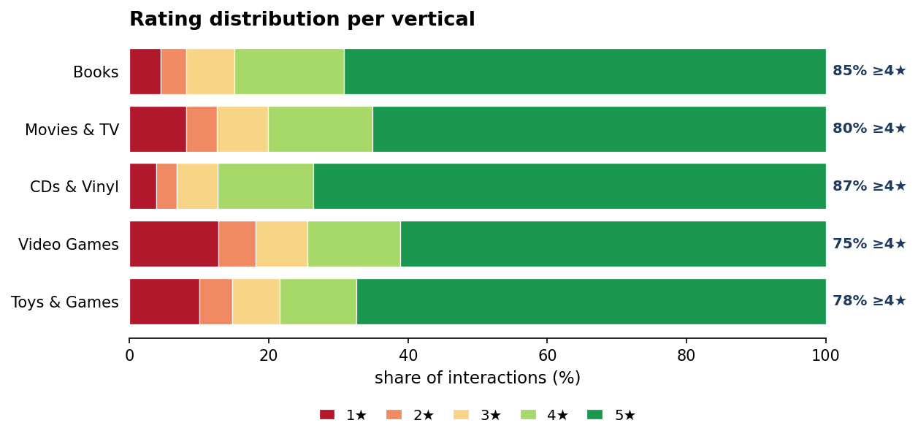
Figure 1. Rating distribution per vertical, as a share of interactions by star rating.
Timestamp coverage. Every vertical spans a long history: first interactions fall in 1996–1998 and the last in September 2023, a 25–27-year window, with volume heavily concentrated in the most recent decade. This concentration matters for the planned time-based split, in which interactions are partitioned chronologically — earlier ones for training, later ones held out for validation and test — so the model is evaluated on predicting future interactions from past ones rather than on a random sample. The dense recent decade leaves enough data on both sides of a recent cut-off for that split to be well-populated.
Sparsity. Both the items-per-user and users-per-item distributions are extremely heavy-tailed. The median user has rated a single item in every vertical, and even the 90th-percentile user has rated no more than five; the long tail is heaviest on the item side, where the 99th-percentile Video Games item is rated 537 times. This fat-head, long-tail shape means cold-start is the norm rather than the exception — precisely the condition the 5-core filter and the cross-domain signal are meant to address.
Metadata completeness. Field population varies sharply by vertical and is the main driver of the pair choice in §2.3. Identifiers and popularity fields (title outside Movies, main_category, average_rating, rating_number) are near-universal, but the rich-text fields the content bridge relies on are uneven: description is populated for only 41–66% of items, and features ranges from essentially absent (CDs & Vinyl 0.2%, Movies & TV 5%) to common (Books 88%, Toys & Games 80%). Movies & TV is the thinnest catalog overall — only 58% of its items even carry a title — which is the caveat attached to the Books→Movies pair in §2.3.
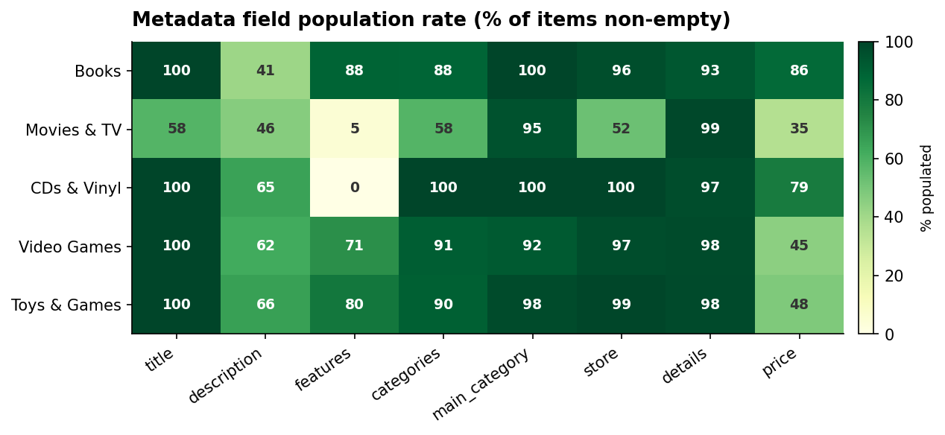
Figure 2. Metadata field population rate by vertical (% of items with a non-empty value).
Category structure. Category paths are present for most items (58–100% by vertical) and each vertical resolves to a single clean root ("Books", "CDs & Vinyl", "Video Games", and so on), confirming that the main_category field carries the live store label rather than the dataset partition. Path depth and breadth are richer in Books and Toys than in the effectively single-node music tree, giving the taxonomy half of the bridge more to work with there.
Join integrity. Within a vertical the ratings and metadata tables join on the item identifier. Intersecting the two key sets shows zero orphan interactions in every vertical — every rated item has a metadata record — so no interactions are dropped for missing metadata at ingest.

2.3 Explore Data
Task Explore Data
This task tackles the data mining questions, which can be addressed using querying, visualization and reporting. These analyses may address directly the data mining goals. However, they may also contribute to or refine the data description and quality reports, and feed into the transformation and other data preparation needed for further analysis.

Output Data Exploration Report
Describes results of this task including first findings or initial hypotheses and their impact on the remainder of the project. The report possibly also covers graphs and plots which indicate data characteristics or lead to interesting data subsets for further examination

The 5-core filter. After filtering, the verticals retain between 0.8M (Video Games) and 9.5M (Books) interactions and between 95k and 776k users. This filtered snapshot is what overlap is measured on.
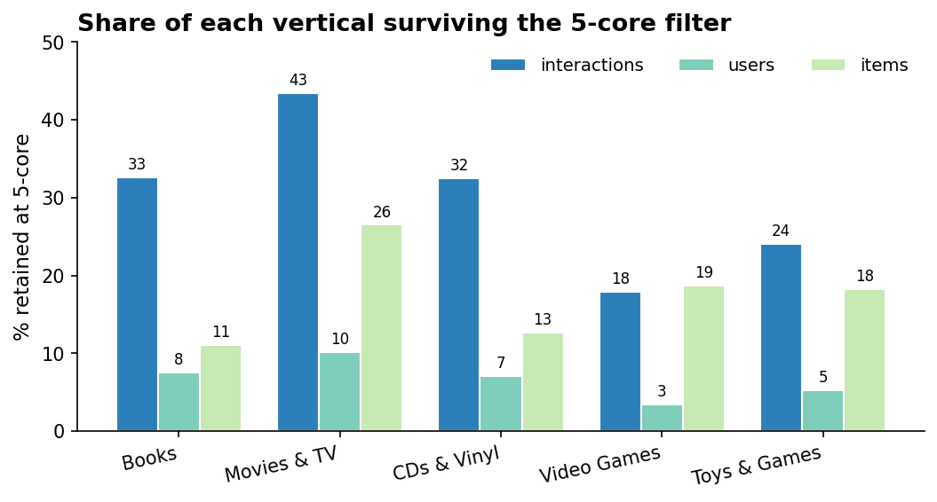
Figure 3. Share of each vertical (interactions, users, items) surviving the 5-core filter.
Pairwise user overlap. Because the corpus uses one user identifier across verticals, shared users are recovered by intersecting user columns. The shared users of a pair are exactly the training set for its source→target mapping — each supplies a (source-embedding, target-embedding) example the mapping learns from — so overlap size decides which pairs are worth modeling at all. Because the project's goal is cross-domain recommendation across every viable pair rather than a single locked pair, overlap is treated as an inclusion filter: the project sets a planning-phase floor of roughly 10,000 shared users, below which the mapping has too few examples to fit reliably, and every pair above the floor becomes an experiment to run. After 5-core, eight of the ten vertical pairs clear the floor; only Toys & Games ↔ CDs & Vinyl (7.75k) and CDs & Vinyl ↔ Video Games (4.4k) fall short. Books anchors the densest pairs — Books → Movies & TV (127k) and Books → Toys & Games (87k) lead by a wide margin — consistent with Books being the largest and most-connected vertical.
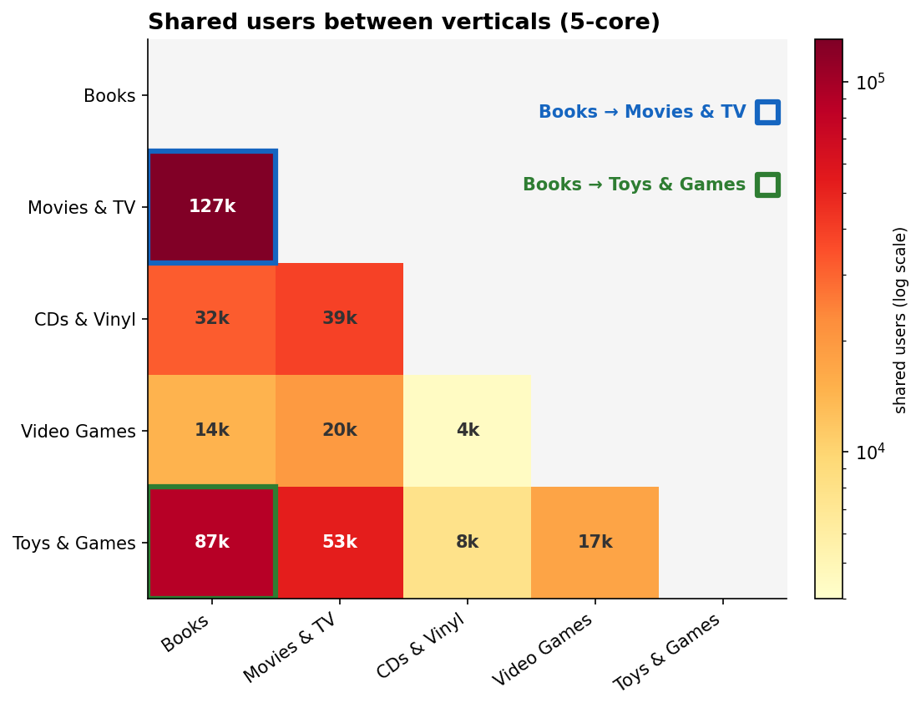
Figure 4. Pairwise shared users after the 5-core filter (log colour scale; the eight pairs above the ~10k floor outlined).
Defining the experiment set. The project runs cross-domain recommendation over every viable vertical pair, not one chosen pair, so overlap is used to admit pairs rather than to select among them. The full ranking of the ten ordered pairs is below; the eight that clear the ~10k floor define the experiment set.
Source → Target | Shared users (5-core) | Clears ~10k? | Avg richness
Books → Movies & TV | 127,188 | yes | 0.65
Books → Toys & Games | 87,225 | yes | 0.81
Movies & TV → Toys & Games | 52,794 | yes | 0.70
Movies & TV → CDs & Vinyl | 38,769 | yes | 0.71
Books → CDs & Vinyl | 32,027 | yes | 0.82
Movies & TV → Video Games | 19,615 | yes | 0.69
Toys & Games → Video Games | 17,202 | yes | 0.85
Books → Video Games | 14,478 | yes | 0.80
Toys & Games → CDs & Vinyl | 7,750 | no | 0.87
CDs & Vinyl → Video Games | 4,399 | no | 0.86
Table 2. All ten ordered source→target pairs ranked by 5-core shared-user overlap; the eight above the ~10k floor (Clears ~10k = yes) form the CDR experiment set. Source is the larger vertical; richness averages title / description / categories population.
The qualifying set. The eight pairs above the floor span a wide density range. Two are dense — Books → Movies & TV (127k) and Books → Toys & Games (87k). Three are mid-range — Movies & TV → Toys & Games (53k), Movies & TV → CDs & Vinyl (39k), and Books → CDs & Vinyl (32k). Three sit just above the floor — Movies & TV → Video Games (20k), Toys & Games → Video Games (17k), and Books → Video Games (14k) — where the mapping is data-limited and results should be read with more caution. Catalog richness no longer selects between pairs; it becomes a per-pair caveat, sharpest for any pair targeting Movies & TV, whose catalog is the thinnest in the snapshot (title 58%, description 47%, features 5%) and forces that pair's content bridge to lean on the source side and on title fallback.
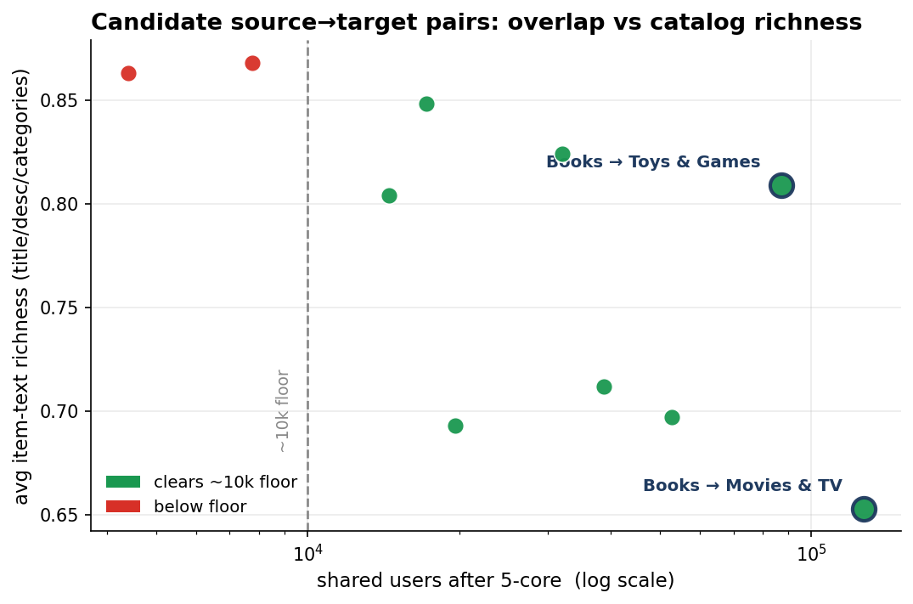
Figure 5. All ten pairs: 5-core overlap (log scale) against average item-text richness; the eight above the floor form the experiment set.
Direction and threshold. Each pair is run source→target with the larger vertical as source, so its denser user histories feed the mapping; this yields eight directed experiments (sixteen if the reverse, sparse→dense direction is added as a symmetric ablation). On the floor itself, the ~10k threshold is kept: it is the established §S2 planning floor, it cleanly admits eight of the ten pairs, and the two it excludes both involve the two smallest verticals (CDs & Vinyl and Video Games). The three pairs in the 14–20k band clear the floor but are borderline and flagged as lower-confidence. The two sub-floor pairs are not dropped permanently — they are R1 contingency candidates, recoverable by relaxing to a 3-core filter, which raises overlap at the cost of a sparser, noisier catalog.
First findings and impact. Four properties carry into the rest of the project: the heavy positive skew supports the binary-positive encoding discussed in §2.1; the pervasive cold-start (most users have one or two interactions) is exactly what cross-domain transfer is meant to relieve; the absence of orphan interactions means no item-side cleaning is needed for the within-vertical join; and the uneven metadata means the content bridge's strength varies across the eight-pair experiment set and must be tracked per pair in §2.4 and §3, rather than resolved by a single pair choice.

2.4 Verify Data Quality
Task Verify Data Quality
Examine the quality of the data, addressing questions such as: Is the data complete (does it cover all the cases required)? Is it correct or does it contain errors, and if there are errors how common are they? Are there missing values in the data? If so, how are they represented, where do they occur and how common are they?

Output Data Quality Report
List the results of the data quality verification; if there are quality problems, list possible solutions.

Completeness. The data covers the cases the project needs. Within each vertical the ratings and metadata tables join fully on the item identifier — zero orphan interactions, so no rated item lacks a metadata record. The interaction keys are complete as well: no row in any vertical is missing a user or item identifier. The one completeness gap is on the content side, addressed next.
Missing values. Missing data is confined to the descriptive metadata fields and is uneven across verticals (Figure 2). Identifiers, ratings, timestamps, and popularity fields are fully populated, but the rich text the content bridge consumes is patchy: description is present for 41–66% of items, features ranges from near-absent (CDs & Vinyl 0.2%, Movies & TV 5%) to common (Books 88%), and Movies & TV is missing a title on 42% of its catalog. Missing values are represented as empty lists or nulls, not coded sentinels. The feature pipeline first falls back to title, store, and details when the richer fields are empty. The residual items with no usable text at all are not dropped but kept with a placeholder content vector — a single shared "no-content" embedding that fills the slot the text encoder would otherwise produce — so the item still participates in the model through its collaborative signal (the users who interacted with it). Removal is avoided deliberately: deleting a text-poor item would also delete every interaction with it, which can cascade into dropping its users and re-introduce the sparsity the 5-core filter just removed, and it would bias the catalog against exactly the cold, long-tail items that cross-domain transfer is meant to help.
Correctness. Three correctness issues surfaced, all minor. First, the rating scale behaves: all five values 1–5 occur, and the only out-of-range entries are four rows in Books that carry a 0 (0.00001% of that table), which are dropped. Second, the main_category field holds the live store label at scrape time, not the dataset partition — a Movies & TV record can read "Comedy" or "Drama" rather than the vertical name — so the source of truth for an item’s vertical is the file it came from, never main_category; the field also mixes synonymous labels for the same vertical, and the free-text categorical fields (categories, store) carry the usual casing and near-duplicate variants, all normalised in §3. Third, bought_together is null for 100% of the 6.9M items in the snapshot; it carries no signal and is dropped.
Duplicates and timestamps. There are zero duplicate (user, item) interactions in any vertical. All timestamps are positive and fall between 1996 and September 2023, so the time axis is safe to use directly for the time-based split.
File structure. The ratings tables are flat comma-separated files; every one of the 71.7M rows across the five verticals parses into exactly four fields, so the delimiter is applied consistently and no record is truncated or misaligned. The metadata is JSON-Lines with one valid record per line.
Risks. Two items cannot be closed here and carry forward. The cross-vertical user join relies on the corpus guarantee that a user identifier denotes the same person in every vertical; this is taken as given, and the consequential quantity — how many such users survive filtering — is the overlap measured in §2.3. And because metadata richness is vertical-dependent, the strength of the content bridge will vary by pair; the thin Movies & TV catalog in particular must be validated against the chosen pair in §3 before it is relied on.

Check | Result over the full snapshot | Action
Orphan interactions (join) | 0 in all verticals | none; keep as a pipeline guard
Null user / item keys | 0 in all verticals | none
Duplicate interactions | 0 in all verticals | none; no de-duplication
Rating values | 1–5, except 4 zero rows in Books | drop the 4 rows
Timestamps | positive, 1996 – Sep 2023 | none; safe for the time split
Flat-file structure | every row parses into exactly 4 fields (71.7M rows) | none
Rich-text fields | uneven (Fig. 2): description 41–66%, features 0.2–88% | title / store / details fallback
main_category | live store label, not the partition | use the file-of-origin label
bought_together | 100% null (6.9M items) | drop at ingest
Cross-vertical user identity | corpus guarantee; overlap quantified in §2.3 | accept; overlap is the gate
Table 3. Data quality summary: checks, results over the full snapshot, and the action for each.

Data Preparation

3.1 Select Data

Task Select data
Decide on the data to be used for analysis. Criteria include relevance to the data mining goals, quality, and technical constraints such as limits on data volume or data types.

Output Rationale for Inclusion / Exclusion
List the data to be used/excluded and the reasons for these decisions

Selection criteria, revisited. Section 2 supplies the evidence this selection rests on: the pairwise user overlap (§2.3), the metadata population rates (§2.2.5), and the zero-orphan ratings–metadata join (§2.2.8). Because the project goal is cross-domain recommendation across every viable vertical pair, selection is two-tiered — which verticals enter the per-vertical pipeline, and which pairs enter the cross-domain experiment.
Verticals included. All five downloaded verticals (Books, Movies & TV, CDs & Vinyl, Video Games, Toys & Games) are retained for per-vertical processing. Eight of the ten pairs they form clear the overlap floor, so processing all five once makes every viable pair available with no rework; none is excluded at this stage.
Pairs included. The cross-domain experiment keeps the eight ordered source→target pairs whose shared-user count clears the planning floor of 10,000 (§2.3). The two sub-floor pairs — Toys & Games ↔ CDs & Vinyl and CDs & Vinyl ↔ Video Games — are excluded and flagged as R1 contingency candidates, recoverable by relaxing the density filter to 3-core. Source is the larger vertical in each pair, so the denser user history supervises the mapping.
Attributes included, and their relative importance. All four ratings fields are kept: user_id and parent_asin (identity), rating (interaction signal), and timestamp (for the temporal split). From the metadata the model-relevant fields are kept — title, description, features (item text); categories and main_category (taxonomy); store, details and author (structured side-information); and average_rating and rating_number (popularity priors). Following CRISP-DM's prompt to weight attributes, the item text and taxonomy are the highest-importance attributes (they are the cross-vertical bridge), the identity and interaction fields are essential, and the popularity priors are secondary. Excluded as irrelevant or unusable: images and videos (URLs only), price (missing for up to 53% of Movies & TV items), subtitle (cosmetic), and bought_together (100% null — §3.2).
Rows included. Each vertical is reduced to its 5-core — users and items with at least five interactions, iterated to stability — applied independently per vertical after the rating-based row drops of §3.2. Table 4 reports the reduction.

Table 4. Per-vertical row selection: 0-core → 5-core after dropping out-of-range and neutral ratings.
Vertical | 0-core interactions | 5-core interactions | Retention % | 5-core users | 5-core items
Books | 29,139,329 | 8,130,341 | 27.9 | 687,023 | 440,134
Movies & TV | 17,158,519 | 6,486,790 | 37.8 | 592,843 | 181,532
CDs & Vinyl | 4,772,071 | 1,370,152 | 28.7 | 112,342 | 80,990
Video Games | 4,555,500 | 682,040 | 15.0 | 80,886 | 22,746
Toys & Games | 16,052,440 | 3,360,986 | 20.9 | 379,869 | 148,572

3.2 Clean Data
Task Clean Data
Raise the data quality to the level required by the selected analysis techniques. This may involve selection of clean subsets of the data, the insertion of suitable defaults or more ambitious techniques such as the estimation of missing data by modeling

Output Data Cleaning Report
This report describes the decisions and actions that were taken to address the data quality problems reported during the Verify Data Quality Tas

Scope. Each data-quality finding from §2.4 maps to one cleaning action. The checks are applied per vertical on the post-selection tables; counts are over the full snapshot.
Out-of-range ratings. The four Books interactions carrying a rating of 0 — the only out-of-range values in any vertical (§2.4) — are dropped. The neutral 3-star ratings are also removed here, but as a labelling decision rather than a quality fix (§3.3): 2,032,688 in Books, 1,248,470 in Movies & TV, 1,090,727 in Toys & Games, 335,256 in Video Games, and 280,338 in CDs & Vinyl.
Universally-null field. bought_together is null for 100% of items in all five verticals — confirmed again on the kept-item subset — and is dropped. No other field is universally empty.
Missing item text — defaults, not deletion. Where the rich-text fields are empty the pipeline falls back to title + store + details before giving up; only items with no usable text at all receive a shared placeholder vector (§3.3), and none is dropped, because deleting a text-poor item would also delete its interactions and re-introduce the sparsity the 5-core filter just removed. The fallback is needed almost entirely in Movies & TV — 106,431 of 181,532 items (59%) carry primary text, 75,097 fall back, and only 4 have no text — while every other vertical is essentially all-primary (Books 440,134 of 440,134). This matches §2.2's finding that Movies & TV is the thinnest catalog (title missing on 41% of kept items, features on 95%).
Categorical normalization. store and each categories path element are lower-cased and whitespace-collapsed to merge casing and near-duplicate variants before they are used as features.
main_category correctness. Because main_category holds the live store label at scrape time rather than the dataset partition (§2.4), every item is stamped with a source_vertical taken from the file it came from; main_category is retained only as a descriptive feature.
Integrity confirmed. The axes §2.4 found clean were re-verified after selection and hold exactly: zero duplicate (user, item) pairs and zero null keys in every vertical, all timestamps positive and within 1996–2023, and zero orphan interactions at the within-vertical join (§3.4). No de-duplication, key repair, or timestamp correction was required.

3.3 Construct Data
Task Construct Data
This task includes constructive data preparation operations such as the production of derived attributes, complete new records, or transformed values for existing attributes.

Output Derived Attributes
Derived Attributes are new attributes that are constructed from one or more existing attributes in the same record. An example might be area =length * width.
Why should we need to construct derived attributes during the course of a data mining investigation? It should not be thought that only data from databases or other sources is the only type of data that should be used in constructing a model. Derived attributes might be constructed because:
Background knowledge convinces us that some fact is important and ought to be represented although we have no attribute currently to represent it.
The modelling algorithm in use handles only certain types of data, e.g. we are using linear regression and we suspect that there are certain nonlinearities that will be not be included in the model.
The outcome of the modelling phase may suggest that certain facts are not being covered.

Interaction label. The training target y is derived from rating: ≥4 → positive (1), 1–2 → explicit negative (0), 3 dropped. The positive share is very high in every vertical — 0.93 Books, 0.88 Movies & TV, 0.94 CDs & Vinyl, 0.89 Video Games, 0.92 Toys & Games — so explicit negatives are scarce (e.g. 566,579 against 7.56M positives in Books), which is what motivates the generated negatives below. A per-row weight carries the explicit-negative up-weighting knob (default 1.0). See Table 5.
Item text embedding. title, description and features are newline-joined and encoded with sentence-transformers/all-MiniLM-L6-v2 into an L2-normalised 384-dimensional vector, cached by SHA-1 of the text so cross-vertical duplicate texts encode once. Inputs are truncated to 256 tokens; a non-trivial tail exceeds this (sequences up to ~1,022 tokens were observed), so long descriptions are clipped. Items with no usable text receive a shared placeholder vector. Coverage follows text availability from §3.2: essentially every Books, CDs & Vinyl, Video Games and Toys item and all but four Movies & TV items have an embeddable text, so a full encoding pass embeds the entire catalog except those four placeholders. (The current run was a smoke pass that materialised only a sample of vectors; the full pass is pending and does not change the design.)
Category multi-hot. The hierarchical categories paths are encoded as a multi-hot vector over a single vocabulary of 3,092 category tokens built across all five verticals, so every vertical sits in one shared category space — enabling the categories-only ablation and cross-vertical comparison.
Popularity priors and normalization. average_rating is passed through (median-filled); rating_number is heavy-tailed, so following CRISP-DM's normalization prompt it is log1p-transformed then z-scored per vertical, with the mean and standard deviation stored for inference. These are candidate item features, secondary to the bridge.

Output Generated Records
Generated Records are completely new records which add new knowledge or represent new data which is not otherwise represented, e.g., having segmented the data, it may be useful to generate a record to represent the prototypical member of each segment for further processing.

Sampled negatives. Implicit-feedback training needs negatives beyond the scarce explicit ones. For every positive interaction, four items the user has never interacted with are drawn uniformly from the vertical's catalog (seeded per vertical for reproducibility); the user's full pre-filter history defines the exclusion set, so a sampled negative is never a hidden positive. This generates 30,255,048 negative rows for Books, 22,854,852 for Movies & TV, 12,390,088 for Toys & Games, 5,136,260 for CDs & Vinyl and 2,417,508 for Video Games, which combine with the labelled positives and explicit negatives into the per-vertical training signal (Books 38.39M rows, Movies & TV 29.34M, Toys & Games 15.75M, CDs & Vinyl 6.51M, Video Games 3.10M). No prototype or aggregate records are generated; these negatives are the only generated records.
Table 5. Per-vertical label distribution, generated negatives, and embeddable-text coverage.
Vertical | Positives | Explicit neg. | Pos. ratio | Sampled neg. | Items (kept) | Text placeholder
Books | 7,563,762 | 566,579 | 0.93 | 30,255,048 | 440,134 | 0
Movies & TV | 5,713,713 | 773,077 | 0.88 | 22,854,852 | 181,532 | 4
CDs & Vinyl | 1,284,065 | 86,087 | 0.94 | 5,136,260 | 80,990 | 0
Video Games | 604,377 | 77,663 | 0.89 | 2,417,508 | 22,746 | 0
Toys & Games | 3,097,522 | 263,464 | 0.92 | 12,390,088 | 148,572 | 0

3.4 Integrate Data
Task Integrate Data
These are methods whereby information is combined from multiple tables or other information sources to create new records or values

Output Merged Data
Merging tables refers to joining together two or more tables that have different information about the same objects. At this stage it may also be advisable to generate new records. It may also be recommended to generate aggregate values.

Aggregation refers to operations where new values are computed by summarizing together information from multiple records and/or tables

Within-vertical merge. Within each vertical the training signal is joined to the item-feature table on parent_asin. The join is complete — 100% coverage in all five verticals, confirming the zero-orphan finding of §2.2.8 on the post-selection data — so no interaction is dropped for missing metadata. The merged per-vertical tables carry the interaction, its label and weight, and the full item feature set.
Cross-vertical bridge. The cross-domain link is built by intersecting the 5-core user sets of each source and target vertical, recovering the shared users that supervise the mapping. For each of the eight pairs the merge produces the matched source→target user set plus the role split (source-only, target-only, overlap). Table 6 reports the result.
Overlap after neutral removal. Because §3 drops 3-star neutrals before the 5-core filter, the user sets are smaller than in the §2.3 exploration and the overlaps are correspondingly lower — Books → Movies & TV is 109,206 here versus 127k in §2.3 — but all eight pairs still clear the 10,000 floor, with Books → Video Games the tightest at 11,801. The pair ranking is unchanged.
Aggregation. The per-user source profile the mapping consumes (the aggregate of a shared user's source-side item embeddings, default mean-pool) is computed at modelling time in §4; §3 persists the matched-pair index and per-side activity counts so that aggregation stays a thin, swappable step.

Table 6. Cross-vertical bridge per pair (5-core, source = larger vertical): shared users, Jaccard, and role-split sizes.
Source → Target | Shared users | Jaccard | Source-only | Target-only
Books → Movies & TV | 109,206 | 0.093 | 577,817 | 483,637
Books → Toys & Games | 75,649 | 0.076 | 611,374 | 304,220
Movies & TV → Toys & Games | 46,024 | 0.050 | 546,819 | 333,845
Movies & TV → CDs & Vinyl | 34,630 | 0.052 | 558,213 | 77,712
Books → CDs & Vinyl | 27,570 | 0.036 | 659,453 | 84,772
Movies & TV → Video Games | 16,504 | 0.025 | 576,339 | 64,382
Toys & Games → Video Games | 14,517 | 0.033 | 365,352 | 66,369
Books → Video Games | 11,801 | 0.016 | 675,222 | 69,085

3.5 Format Data
Task Format Data
Formatting transformations refer to primarily syntactic modifications made to the data that do not change its meaning, but might be required by the modeling too.

Output Reformatted Data
Some tools have requirements on the order of the attributes, such as the first field being a unique identifier for each record or the last field being the outcome field the model is to predict.

Temporal split. Each vertical's interactions are sorted by timestamp and cut chronologically into 80% train / 10% validation / 10% test, so the model is evaluated on predicting later interactions from earlier ones. Both sides of every cut are well-populated thanks to the dense recent decade (§2.2.3): train/validation boundaries land in 2017–2021 and validation/test in 2019–2022 depending on the vertical (Table 7).
Identifier remapping. user_id and parent_asin string tokens are remapped to contiguous integer indices required by embedding-table models. For the per-vertical baselines the vocabulary is per vertical; for each cross-domain pair a pair-global user index is used so a shared user carries the same index on both the source and target sides.
Schema and storage. The reformatted interaction records follow a fixed schema — user_idx, item_idx, label, weight, rating, timestamp, split — identifiers first, with the same layout for the single-vertical and cross-domain inputs so the comparison stays like-for-like. Interactions and seen-item sets are written as Parquet; the per-item feature block (text embedding, category multi-hot, popularity priors, ASIN map) is written as a compressed NPZ. The full §3 output is ~5.7 GB across the five per-vertical datasets and eight pair datasets.
Table 7. Per-vertical temporal split sizes and chronological cut-off dates.
Vertical | Train | Validation | Test | Train end | Val end
Books | 30,708,311 | 3,838,539 | 3,838,539 | 2019-09-02 | 2021-04-23
Movies & TV | 23,473,313 | 2,934,164 | 2,934,165 | 2018-05-01 | 2020-02-07
CDs & Vinyl | 5,205,129 | 650,641 | 650,642 | 2017-08-25 | 2019-07-25
Video Games | 2,479,638 | 309,955 | 309,955 | 2019-11-21 | 2021-06-23
Toys & Games | 12,600,859 | 1,575,107 | 1,575,108 | 2021-07-04 | 2022-09-18

